**TITLE-**

**The Effect of Exchange Rate and GDP on Trade in India**

**COLLEGE-**

**Shyama Prasad Mukherji College for Women**

**University Of Delhi**

**SUBJECT-**

**Applied Econometrics**

**TEACHER INCHARGE**

**Ms. Gita Golani**

**PROJECT BY-**

**VRINDA CHADHA , ASHMITA KOTNALA**

**ABSTRACT-**

In this paper we have tried to understand the relationship between a country’s Gross Domestic product, and the Official Exchange Rate. In this paper we have regressed Trade on these two factors using OLS, and tried to understand the effect of Gross Domestic product and the Official Exchange Rate on Trade.

**INTRODUCTION**

Countries trade with each other when, on their own, they do not have the resources, or capacity to satisfy their own needs and wants. By developing and exploiting their domestic scarce resources, countries can produce a surplus, and trade this for the resources they need.

Clear evidence of trading over long distances dates back at least 9,000 years. Today, international trade is at the heart of the global economy and is responsible for much of the development and prosperity of the modern industrialized world. It benefits us in various ways,

The exploitation of a country’s comparative advantage, which means that trade encourages a country to specialize in producing only those goods and services which it can produce more effectively and efficiently, and at the lowest opportunity cost.

Producing a narrow range of goods and services for the domestic and export market means that a country can produce at higher volumes, which provides further cost benefits in terms of economies of scale.

Trade increases competition and lowers world prices, which provides benefits to consumers by raising the purchasing power of their own income, and leads to a rise in consumer surplus.

Trade also breaks down domestic monopolies, which face competition from more efficient foreign firms.

The quality of goods and services is likely to increase as competition encourages innovation, design and the application of new technologies. But what factors affect trade between two countries? Because international trade can significantly affect a country’s economy, it is important to identify and monitor the factors that influence it.

Many various factors, such as political, economic, and practical factors can affect the growth of international trade. Exchange rates, competitiveness, growing globalization, tariffs and trade barriers, transportation costs, languages, cultures, various trade agreements affect countries by their decision to trade internationally.

The data has been taken from World Bank and presented as follows

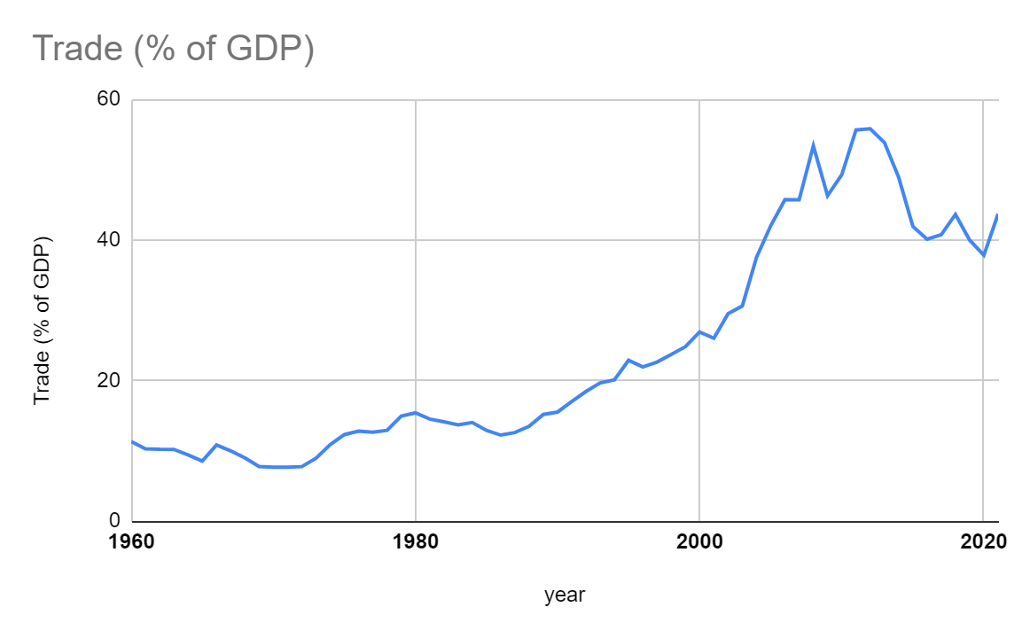

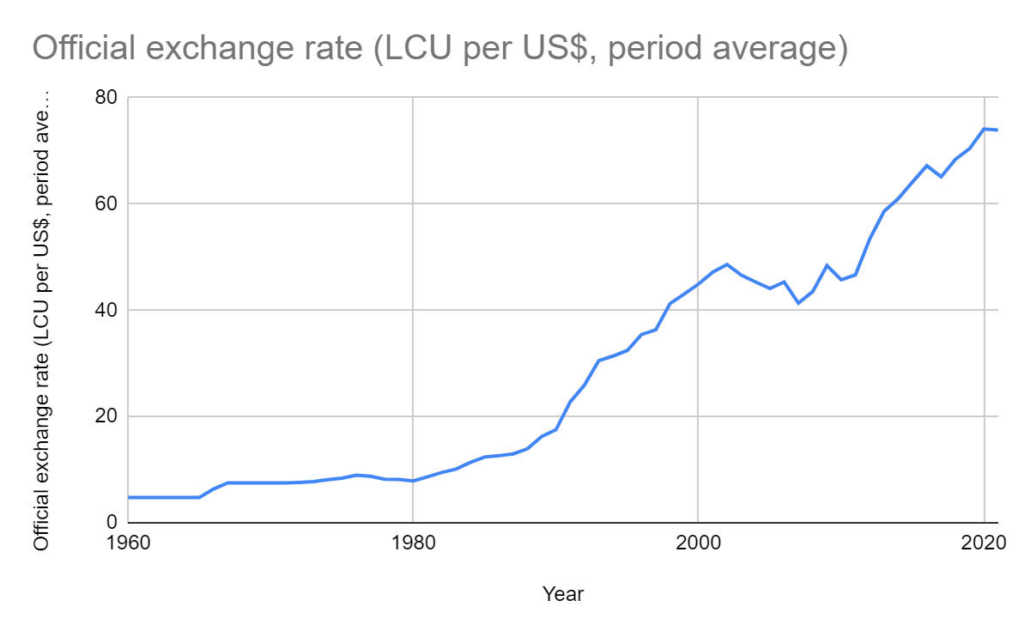

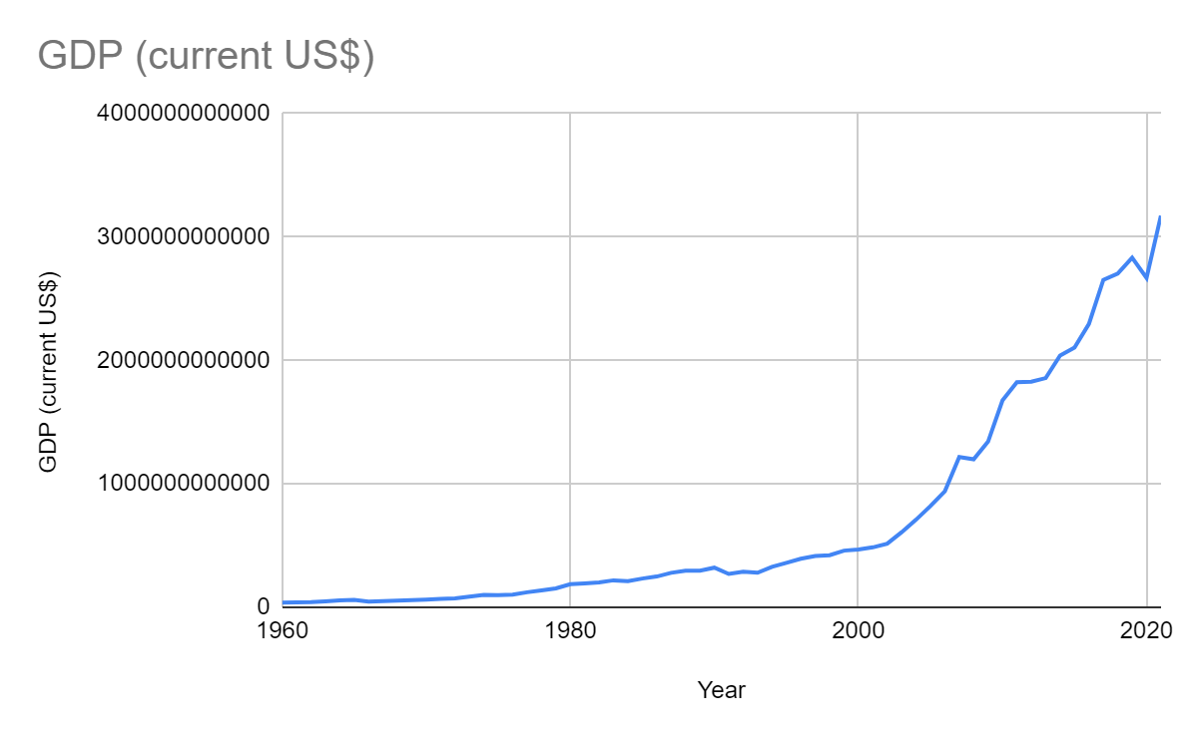

**OBJECTIVES -**

This study has the following objectives -

1. To see the effect of **Exchange Rate** on **Trade.**
2. To see the effect of **GDP** on **Trade.**

**RESEARCH METHODOLOGY -**

We have used the data on Trade(% of GDP), Official Exchange Rate and GDP of India.

Here we are trying to find out whether exchange rate and GDP has a significant effect on trade or not.

**Trade(% of GDP)** is the sum of exports and imports of goods and services measured as a share of Gross Domestic Product.It tells us about the international transactions done by a country.

**Official Exchange Rate** is the price of a country’s money in relation to another country’s money. Exchange rate is important for trade purposes and dynamics of capital flow.

**Gross Domestic Product** is the total value of goods and services produced in a country for a particular period.

In this paper we have used secondary data taken from the World Bank. We have used time series data to show the results, to examine we have taken a time period of 62 years (1960-2021) and 20 years(2002-2021). To check whether the data is efficient or not or does it contain multicollinearity, heteroskedasticity or autocorrelation various tests have been done with the help of Gretl software. Also to alleviate the problems use of remedial measures has been done using the same software.

To simplify the analysis data has been presented with the help of graphs, with excel.

Further the analysis has been done and stated descriptively.

**SUMMARY OUTPUT -**

1. **The model with T=20**

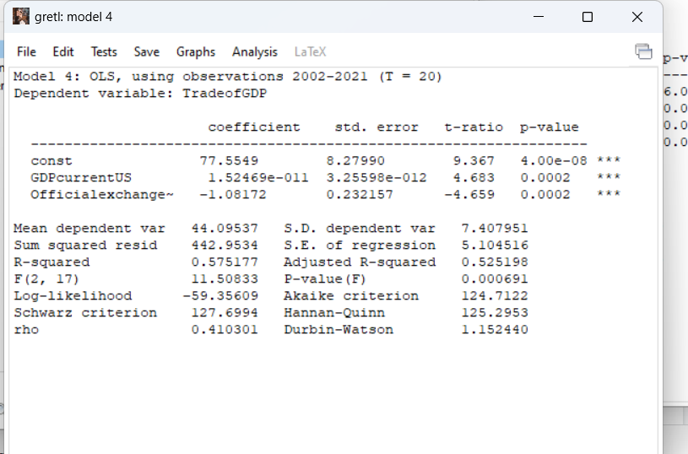

**Test of hypotheses:**

This section of study is used to test the significance of the numerical values of the parameter estimates of the OLS regression. Here, the t‐statistics and values are required.

**Testing of Significance of GDP**

Hypothesis 1

Ho: β3 = 0: There is no significant effect of GDP on trade .

Ha: β3 ≠ 0: There is a significant effect of GDP on trade .

Decision: Do not reject Ho if t 20 , 0.05> t Statistics

Reject Ho and accept Ha if t20 , 0.05 < t Statistics

t20 , 0.05  = 1.725

t Statistics = 4.683

As t20, 0.05 < t Statistics it means we reject the null hypothesis andtherefore it is concluded that gdp has significant effect on trade.

**Testing of Significance of Exchange rate**

Hypothesis 2

Ho: β2 = 0: There is no significant effect of Exchange rate on trade .

Ha: β2 ≠ 0: There is a significant effect of the Exchange rate on trade .

Decision: Do not reject Ho if t 20 , 0.025> t Statistics

Reject Ho and accept Ha if t20 , 0.025 < t Statistics

t 20,0.025 = 2.086

t Statistics = 4.659

As t20, 0.025 < t Statistics it means we reject the null hypothesis andtherefore it is concluded that Exchange rate has a significant effect on trade.

**NOW WE CHECK FOR ANY VIOLATION OF CLRM ASSUMPTIONS IN THE REGRESSION**

**HETEROSKEDASTICITY**

**We use White’s test heteroskedasticity to check for any Heteroskedasticity in our model .**

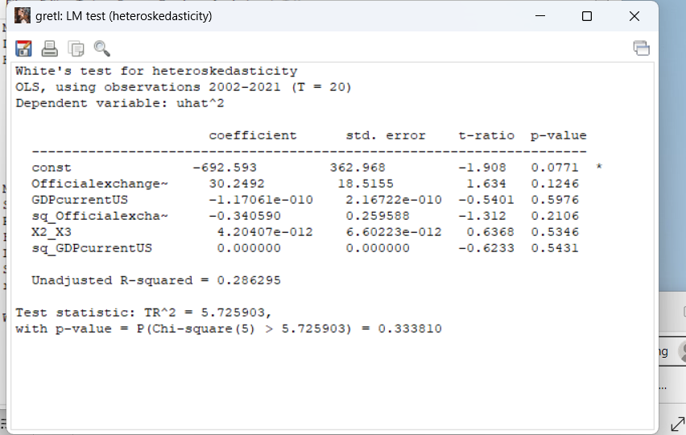

**Analysis**

H0: Heteroskedasticity is not present

HA : Heteroskedasticity is present

Decision: Do not reject Ho if t4 , 0.05> t Statistics

Reject Ho and accept HA if t4 , 0.05 < t Statistics

t4 , 0.05 = 9.488

t Statistics = 5.725903

As t4 , 0.05 > t Statistics it means we do not reject the null hypothesis andtherefore it is concluded that heteroskedasticity is not present in the model.

**MULTICOLLINEARITY**

We use the variance inflation factor to check for any multicollinearity.We observe that the VIF is more than 5, which means it is a cause for concern about multicollinearity .

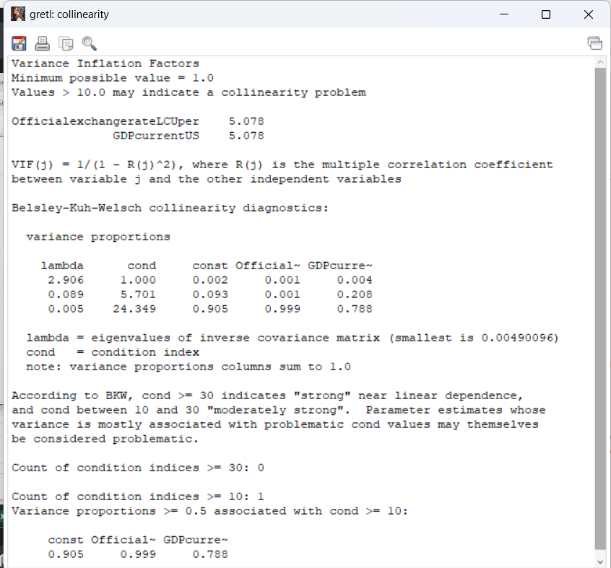

**REMEDIAL MEASURES -**

The variance inflation factor was > 5 in the above model which was a cause for concern as there could be multicollinearity in the model therefore , as a remedial measure the sample size was increased from 20 to 62.

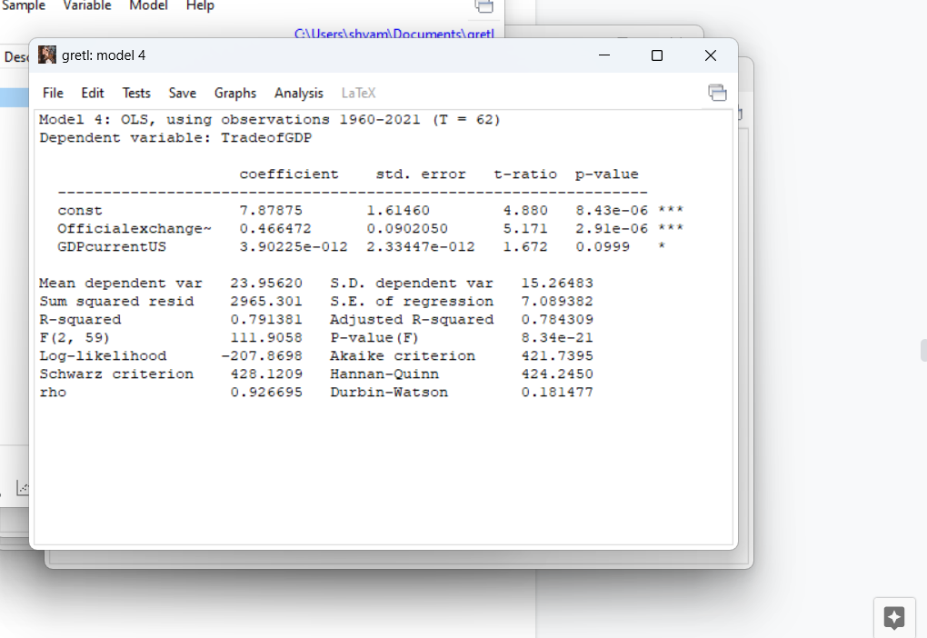

**Test of hypotheses:**

This section of study is used to test the significance of the numerical values of the parameter estimates of the OLS regression. Here, the t‐statistics and values are required.

**Testing of Significance of GDP**

Hypothesis 1

Ho: β3 = 0: There is no significant effect of GDP on trade .

Ha: β3 ≠ 0: There is a significant effect of GDP on trade .

Decision: Accept Ho if t 60 , 0.05> t Statistics

Reject Ho and accept Ha if t60 , 0.05 < t Statistics

t 60 , 0.05 = 1.6

t Statistics = 1.671

As t60, 0.05 < t Statistics it means we reject the null hypothesis andtherefore it is concluded that gdp has significant effect on trade.

**Testing of Significance of Exchange rate**

Hypothesis 1

Ho: β2 = 0: There is no significant effect of Exchange rate on trade .

Ha: β2 ≠ 0: There is a significant effect of Exchange rate on trade .

Decision: Accept Ho if t 60 , 0.025> t Statistics

Reject Ho and accept Ha if t60 , 0.025 < t Statistics

t 60 , 0.050 = 2.00

t Statistics = 5.171

As t60, 0.05 < t Statistics it means we reject the null hypothesis andtherefore it is concluded that Exchange rate has a significant effect on trade.

**.ANOVA TABLE**

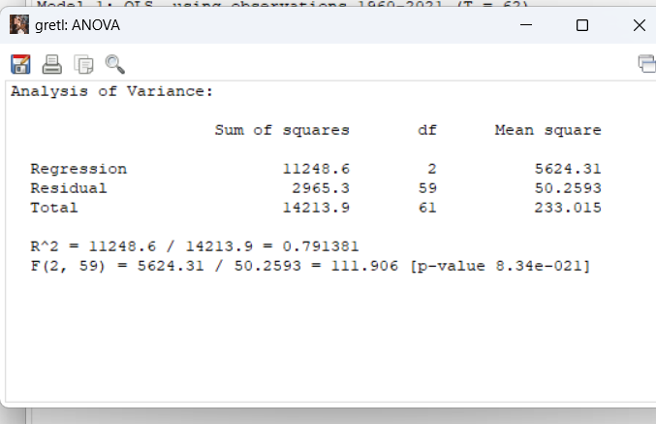

**R square (R2) equals 0.791381. It means that the predictors (Xi) explain 79% of the variance of Y.**

**NOW WE CHECK FOR ANY VIOLATION OF CLRM ASSUMPTIONS IN OUR NEW MODEL:**

**MULTICOLLINEARITY**

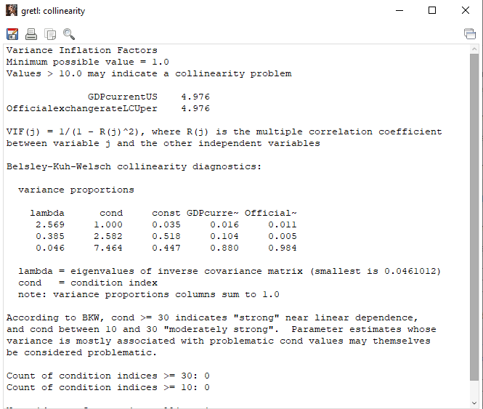

The variance inflation factor is < 5 in the above model which implies that there is low possibility of multicollinearity in the model.

**HETEROSKEDASTICITY**

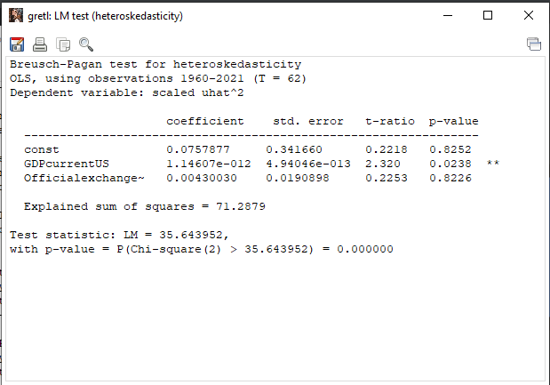

H0: Heteroskedasticity is not present

HA : Heteroskedasticity is present

Decision: Do not reject Ho if t2 , 0.05> t Statistics

Reject Ho and accept HA if t2 , 0.05 < t Statistics

t2 , 0.05 = 5.992

t Statistics = 35.643952

As t3 , 0.05 < t Statistics it means we reject the null hypothesis andtherefore it is concluded that heteroskedasticity is present in the model.

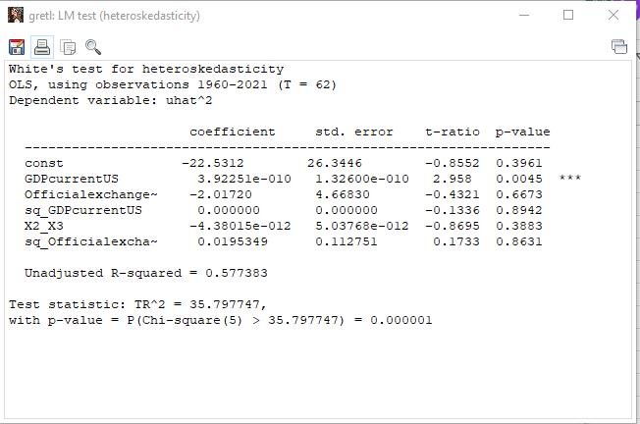

H0: Heteroskedasticity is not present

HA : Heteroskedasticity is present

Decision: Do not reject Ho if t 4, 0.05> t Statistics

Reject Ho and accept HA if t 4 , 0.05 < t Statistics

t4 , 0.05 = 9.488

t Statistics = 35.643952

As t3 , 0.05 < t Statistics it means we reject the null hypothesis andtherefore it is concluded that heteroskedasticity is present in the model.

**AUTOCORRELATION**

We check for any autocorrelation in our new model with T = 62

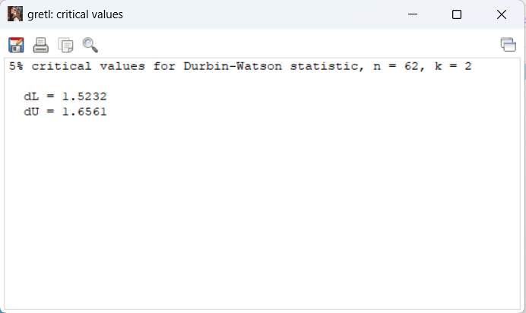

**Test for hypothesis**

d = 0.181477

Ho: 0 < d < dL  positive autocorrelation

dL < d < dU indecisive

du < d < 2 no autocorrelation

dU = 1.6561

dL = 1.5232

0 < 0.181477 < 1.6561

We observe 0 < d < dL , so we conclude positive autocorrelation exists in our model

**Remedial Measure**

We have used the **Praise Winston transformation** to correct the problem of autocorrelation.

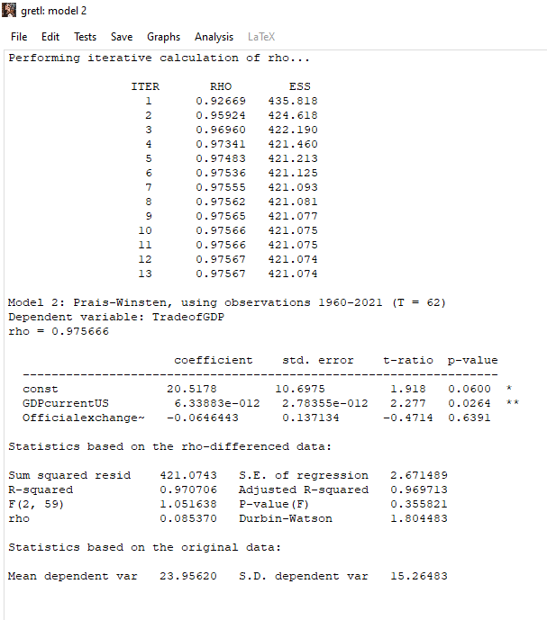

d =1.8044

Ho: 0 < d < dL  positive autocorrelation

dL < d < dU indecisive

du < d < 2 no autocorrelation

dU = 1.6561

dL = 1.5232

1.6561 < 1.8044 < 2 no autocorrelation

We observe du < d < 2, so we conclude positive autocorrelation exists in our model

**Specification error**

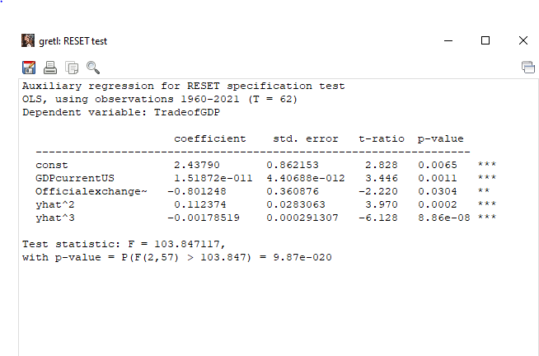

**Test of hypothesis**

**We use Ramsey RESET test to detect any specification error in our model.**

Ho: The coefficient of y^2 = the coefficient of y^3.

Ha: At least one of the coefficients is non zero .

Do not Reject when Ftab > Fcal

Reject when Ftab < Fcal

F2 , 57 = 3.158

Fcalculated = 103.847117

We observe F2 , 57 = 3.158 < Fcalculated = 103.847117

So we reject the Ho and conclude the unrestricted model with five variables is better than the restricted model. Ramsey RESET tells us that an important variables has been omitted in our model with T=62.

**ACTUAL AND FITTED MODEL**

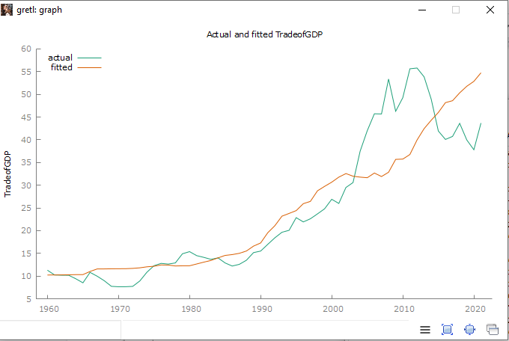

We have shown the actual and fitted regression line of our model in the above graph. We conclude that our estimated line fits the data till year 2002.

**CONCLUSION -**

The above hypothesis , trends and patterns show that-

· Trade( percentage of GDP) has gained momentum and has increased many folds in the past 2 decades in India. It has become an important and big component of aggregate demand.

· Trade is a function of GDP and exchange rate.

· Trade has an inverse relation with the exchange rate . It is a significant relationship as A lower-valued currency makes a country's imports more expensive and its exports less expensive in foreign markets. A higher exchange rate can be expected to worsen a country's balance of trade and hence more imports than exports, while a lower exchange rate can be expected to improve it.

· Trade has a direct relation with GDP, that is when the GDP or the income of the people rise, they tend to spend more and the demand of both the home and foreign products increase.

This study had various limitations. This study was done at an undergraduate level therefore, there were various constraints involved like the lack of time and money. The data for data before 1960 isn’t available on the sites.

**REFERENCES -**

1. World Bank, World Development Indicators, The World Bank Group, last updated:02/15/2022 ,<https://databank.worldbank.org/source/world-development-indicators>

2 <https://www.investopedia.com/trading/factors-influence-exchange-rates/>

[3. 7 Most Influential Factors Affecting Foreign Trade](https://www.yourarticlelibrary.com/foreign-trade/7-most-influential-factors-affecting-foreign-trade/5938)